Plasmit Global Hospital Management System
FHIR & HL7 Ready Multi-Tenant HMS Database Architecture and Module Blueprint

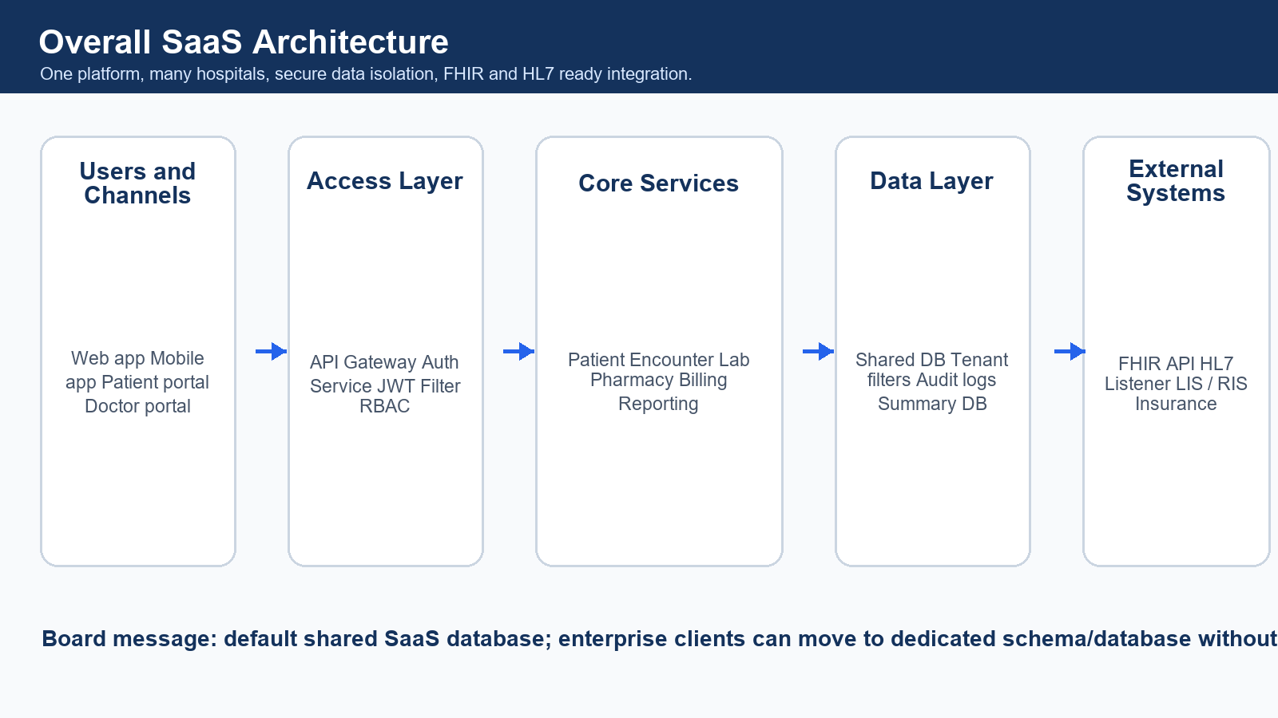
Visual summary of the recommended SaaS architecture.
Item | Detail
Document Version | 2.0 Visual Blueprint
Prepared For | Product, Engineering, Architecture, Compliance and Leadership Teams
Prepared By | Plasmit Engineering Team
Document Style | Board-level summary plus technical implementation blueprint
Recommended Model | Hybrid multi-tenant SaaS: shared tables by default, optional dedicated schema/database for enterprise clients

Table of Contents
- 1. Executive Summary
- 2. One-Page Architecture Decision
- 3. Key Design Goals
- 4. Multi-Tenant Hospital Scenarios
- 5. Recommended Data Hierarchy
- 6. Data Isolation and Security Model
- 7. FHIR and HL7 Integration Strategy
- 8. Database Design Strategy
- 9. Core Foundation Tables
- 10. Complete Hospital Module Blueprint
- 11. Module to FHIR Mapping
- 12. Branch-Level Access Matrix
- 13. API and Microservices Alignment
- 14. Reporting, Analytics and AI Readiness
- 15. Backup, Disaster Recovery and Enterprise Deployment
- 16. Implementation Roadmap
- 17. Final Recommendations
- 18. Appendix

1. Executive Summary
Board-level conclusion
- Use a hybrid multi-tenant database architecture.
- Default SaaS customers should use shared database and shared tables.
- Every transaction row must contain tenant_id, hospital_id and branch_id.
- Large enterprise or government customers can receive dedicated schema or database.
- FHIR and HL7 should be integration layers on top of the normalized HMS database.

- Healthcare SaaS must protect patient, billing and clinical data across many unrelated hospitals.
- Branch-level control is mandatory because the same hospital can operate multiple branches, wards, labs and pharmacies.
- The internal database should remain normalized for operational correctness.
- Reporting, dashboards and AI should use denormalized summary tables, not heavy live transactional queries.
- HL7 v2 is required for legacy HIS, LIS, RIS, analyzers and equipment integrations.
- FHIR is required for modern REST/JSON interoperability with external EHR, insurance, national health networks and partner systems.

2. One-Page Architecture Decision

The platform architecture in one visual.
Decision Area | Recommended Choice | Why It Matters
Default SaaS database | Shared database + shared tables | Lowest cost, fastest rollout, easier upgrades and centralized reporting.
Isolation columns | tenant_id, hospital_id, branch_id | Prevents hospital and branch data mixing when enforced by backend queries.
Enterprise option | Dedicated schema/database | Supports compliance-heavy, large hospital chain and government deployments.
Clinical model | Encounter-centric | OPD, IPD, ER, virtual and day-care workflows connect through Encounter.
FHIR strategy | Mapping/API layer | Expose interoperable resources without copying FHIR blindly as all database tables.
HL7 strategy | Integration engine flow | Listener, parser, validator, message log, normalized table mapping and outbound events.
Reporting | Summary tables and jobs | Dashboards remain fast and do not overload transactional tables.

3. Key Design Goals
Goal | Point-wise Requirement
Global scalability | Support clinics, single hospitals, hospital groups, enterprise chains and government deployments.
Multi-tenant SaaS readiness | One SaaS platform can host many unrelated hospitals safely.
Hospital-wise isolation | One hospital must never see another hospital's operational, clinical or financial data.
Branch-wise isolation | Users must see only authorized branch data unless explicit cross-branch permission exists.
FHIR readiness | Expose Patient, Encounter, Observation, ServiceRequest, DiagnosticReport, MedicationRequest and billing resources.
HL7 readiness | Support ADT, ORM, ORU, SIU, DFT and MDM flows for legacy systems and equipment.
Auditability | Every clinical, financial, integration and access action should be traceable.
AI readiness | Create trusted summary layers for command center, predictions and operational insights.

4. Multi-Tenant Hospital Scenarios
Scenario | Example | Recommended Database Approach | When to Use
Single hospital, single branch | Small hospital | Shared tables with one hospital_id and one branch_id | Default SaaS onboarding.
Single hospital, multiple branches | City hospital with 3 locations | Shared tables with branch_id filters | Most practical branch model.
Hospital group, multiple hospitals | Group owns multiple hospitals | Shared tables under one tenant_id and multiple hospital_id values | Group-level dashboards and governance.
Many unrelated SaaS hospitals | Cloud platform serving many clients | Shared database and shared tables | Default product scale model.
Enterprise separate schema | Large private hospital | Shared server, separate schema per hospital | Contract requires stronger logical isolation.
Enterprise separate database | Government hospital chain | Dedicated database or cluster | Maximum isolation, legal or national deployment needs.
Patient visits multiple branches | Same patient visits two branches | Patient hospital-level, encounters branch-level | Clinical continuity within same hospital.
Platform super admin | Support and subscription team | Access SaaS metadata only by default | No clinical access unless audited break-glass approval exists.

Important design rule
- Patient identity can be hospital-level or tenant-level depending on business policy.
- Encounter, orders, invoices, pharmacy stock and lab work are always branch-level operational records.
- Cross-branch visibility must be permission-driven, not UI-driven.

5. Recommended Data Hierarchy
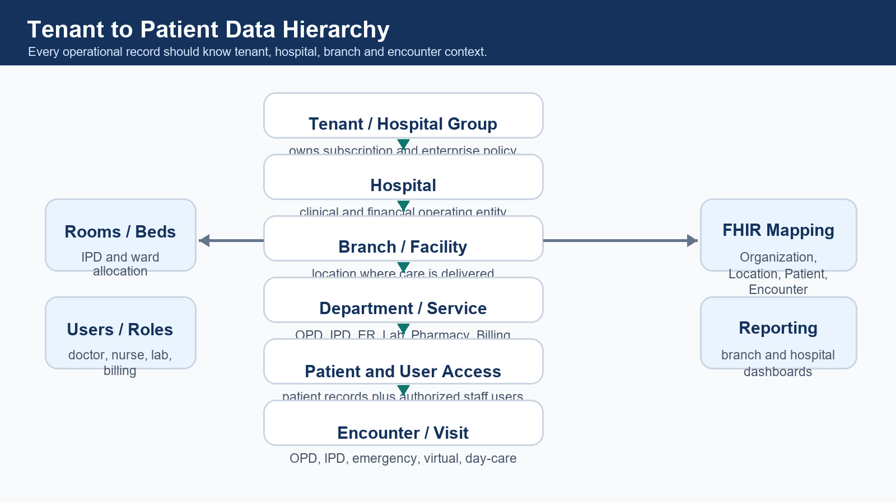
Recommended tenant to encounter hierarchy.
- Tenant represents a hospital group, SaaS customer or enterprise organization.
- Hospital represents the legal and operational healthcare institution.
- Branch or facility represents the physical care location.
- Department represents services such as OPD, IPD, ER, Lab, Radiology, Pharmacy and Billing.
- Patient is the person receiving care.
- Encounter is the care event that connects clinical, diagnostic, medication, billing and discharge workflows.

6. Data Isolation and Security Model
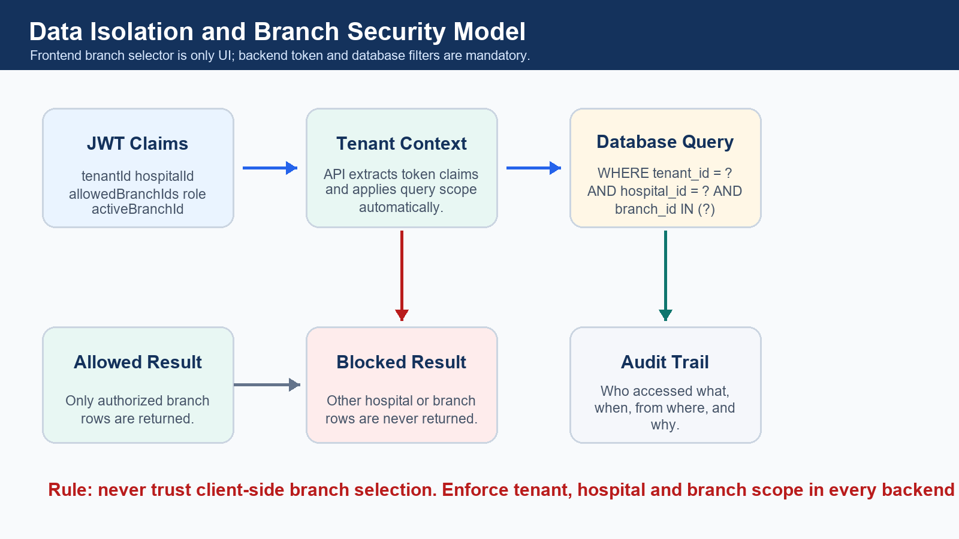
Mandatory backend-enforced tenant, hospital and branch isolation.

JWT Claims Example
{
"userId": 101,
"tenantId": 1,
"hospitalId": 10,
"allowedBranchIds": [100, 101],
"activeBranchId": 100,
"role": "HOSPITAL_ADMIN"
}

Mandatory Query Pattern
WHERE tenant_id = :tenantId
AND hospital_id = :hospitalId
AND branch_id IN (:allowedBranchIds)
AND is_deleted = 0

- Frontend branch selector must not be trusted for security.
- Backend JWT filter should create TenantContext and BranchContext.
- Every service method and SQL query should apply the context.
- Clinical data access should be audited separately from operational metadata access.
- Emergency break-glass access must be time-bound, reason-based and heavily audited.

7. FHIR and HL7 Integration Strategy
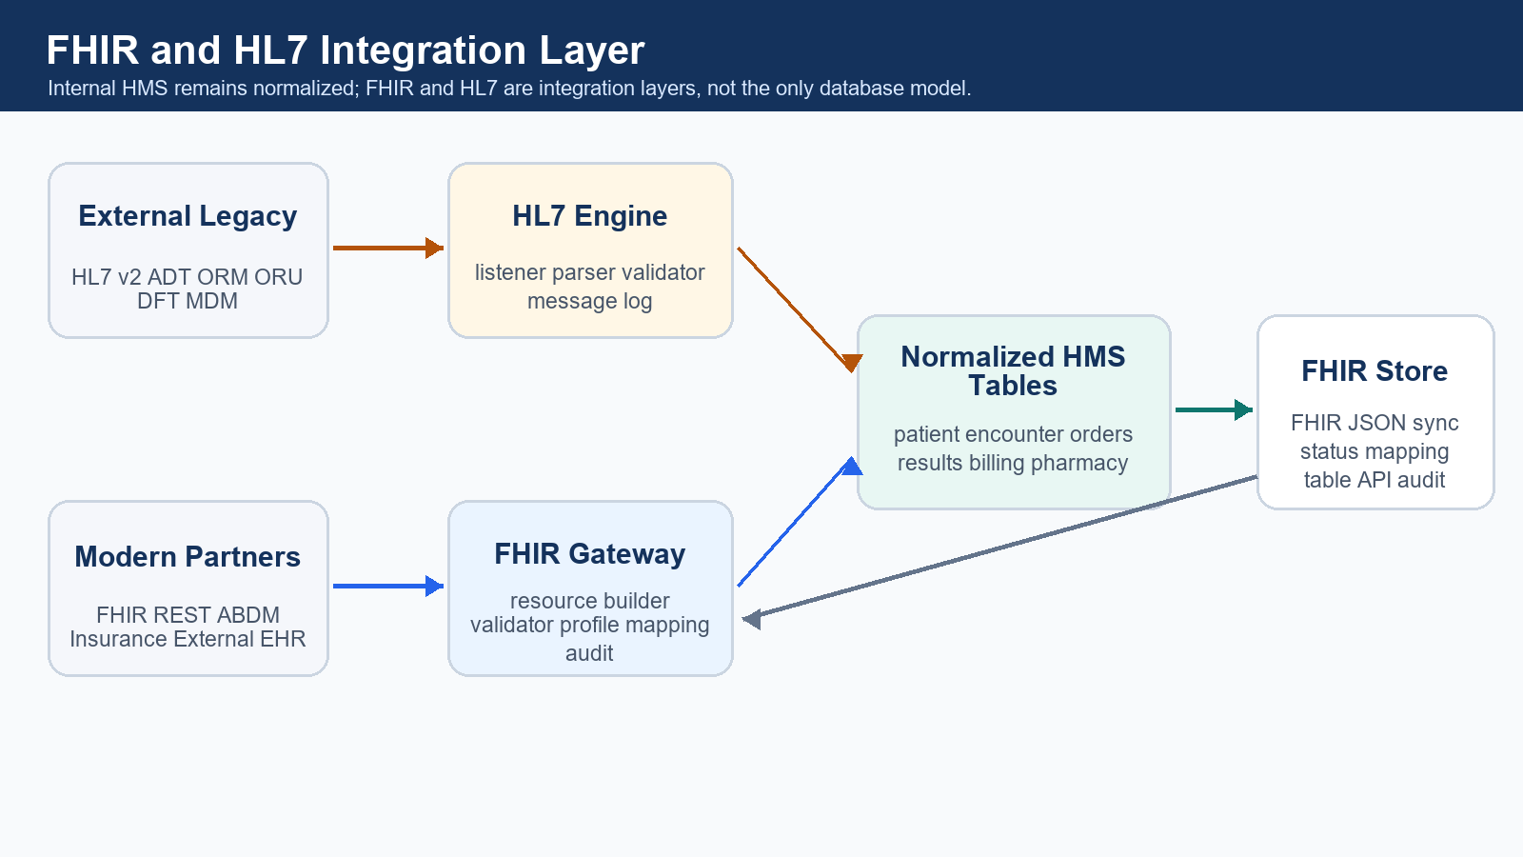
Integration layer keeps HL7 and FHIR separate from the internal operational model.
Integration | Best Use | Key Flow | Database Support
HL7 v2 | Legacy HIS, LIS, RIS, analyzers, machines | Listener -> parser -> validator -> message log -> internal tables | hl7_message_log, hl7_message_segments, integration_error_log
FHIR | Modern REST/JSON APIs, external EHR, insurance, national health networks | Internal tables -> mapper -> resource builder -> validator -> FHIR API | fhir_resource_mapping, fhir_resource_store, fhir_api_audit_log
Internal HMS | Daily hospital operations | Normalized transaction tables | patients, encounters, orders, results, invoices, payments

Core FHIR Resource Mapping
HMS Concept | Internal Table | FHIR Resource | Purpose
Tenant or hospital | tenants, hospitals | Organization | Represent healthcare organization.
Branch or facility | branches | Location | Represent branch, facility, ward, room or bed.
Doctor or clinician | users, doctors | Practitioner | Represent clinical professional.
Doctor branch role | practitioner_roles | PractitionerRole | Represent role in a branch or department.
Patient | patients | Patient | Person receiving care.
Appointment | appointments | Appointment | Scheduling and visit planning.
Visit or admission | encounters | Encounter | OPD, IPD, ER, virtual or day-care care event.
Vitals or lab value | vitals, lab_results | Observation | Measurements, vital signs, lab values and clinical observations.
Lab or radiology order | lab_orders, radiology_orders | ServiceRequest | Diagnostic and procedure order request.
Diagnostic report | diagnostic_reports | DiagnosticReport | Structured result/report output.
Prescription | prescriptions | MedicationRequest | Medication order or prescription.
Medicine master | medicines | Medication | Medication catalog and reference.
Document | documents | DocumentReference | Reports, notes, scans, PDFs and uploaded files.
Billing charge | billing_invoice_items | ChargeItem | Clinical or billing charge item.
Insurance claim | insurance_claims | Claim | Insurance claim submission.
Audit | audit_logs | AuditEvent | Trace data access and changes.

8. Database Design Strategy
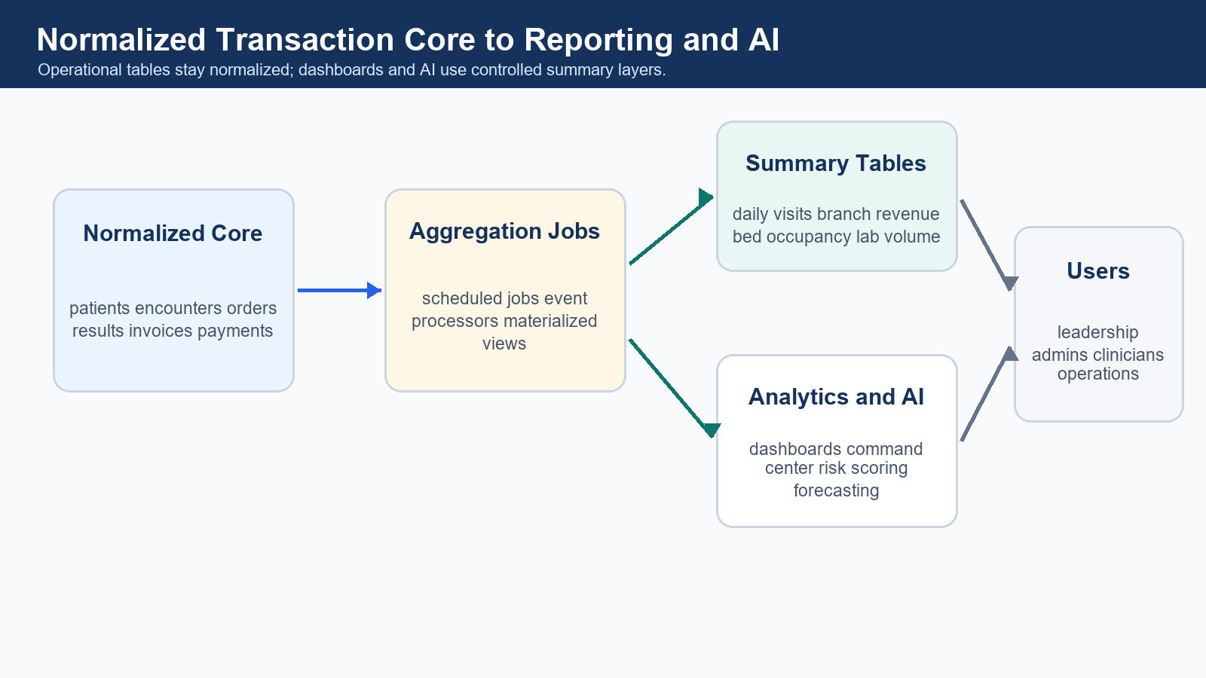
Normalized operational database feeds denormalized dashboards and AI summaries.
Layer | Use For | Examples | Design Notes
Normalized transaction core | Real-time operations | patients, encounters, prescriptions, lab_orders, invoices | Strong foreign keys, clean updates, less duplication, better FHIR mapping.
Denormalized reporting layer | Dashboards and command center | daily_branch_revenue_summary, bed_occupancy_summary | Updated by scheduled jobs or events; do not overload core tables.
FHIR resource store | External interoperability | fhir_resource_store, fhir_sync_status | Store generated/received FHIR payloads and mapping references.
Audit and integration logs | Compliance and traceability | audit_logs, fhir_api_audit_log, hl7_message_log | Never delete important compliance logs without retention policy.

Normalized Transaction Examples
- patients, patient_identifiers, patient_addresses
- encounters, encounter_diagnoses, vitals, clinical_notes
- prescriptions, prescription_items, medication_administration
- lab_orders, lab_order_items, specimens, lab_results
- billing_invoices, billing_invoice_items, payments, refunds
- medicine_batches, pharmacy_stock, pharmacy_sales, stock_movements

Denormalized Summary Examples
- daily_branch_revenue_summary
- daily_patient_visit_summary
- department_wise_collection_summary
- doctor_performance_summary
- pharmacy_stock_snapshot
- lab_test_volume_summary
- bed_occupancy_summary
- patient_journey_summary

9. Core Foundation Tables
Domain | Main Tables | Isolation Columns | FHIR Mapping
SaaS and organization | tenants, hospitals, branches, departments, healthcare_services | tenant_id, hospital_id, branch_id where applicable | Organization, Location, HealthcareService
Users and access | users, roles, permissions, user_branch_access, audit_logs | tenant_id, hospital_id, branch_id | Practitioner, PractitionerRole, AuditEvent
Patient and visit | patients, patient_identifiers, patient_addresses, appointments, encounters | tenant_id, hospital_id, branch_id on operational rows | Patient, Appointment, Encounter
Clinical core | vitals, diagnoses, clinical_notes, allergies, care_plans, procedures | tenant_id, hospital_id, branch_id, encounter_id | Observation, Condition, AllergyIntolerance, CarePlan, Procedure
Diagnostics | lab_orders, lab_order_items, lab_results, radiology_orders, radiology_reports | tenant_id, hospital_id, branch_id | ServiceRequest, Observation, DiagnosticReport
Pharmacy | medicines, medicine_batches, pharmacy_stock, prescriptions, prescription_items, pharmacy_sales | tenant_id, hospital_id, branch_id | Medication, MedicationRequest, MedicationDispense
Billing and insurance | billing_invoices, billing_invoice_items, payments, refunds, insurance_claims | tenant_id, hospital_id, branch_id | Account, ChargeItem, Claim, ExplanationOfBenefit
Documents and integration | documents, fhir_resource_store, fhir_resource_mapping, hl7_message_log | tenant_id, hospital_id, branch_id | DocumentReference, AuditEvent

10. Complete Hospital Module Blueprint
Module | Purpose | Key Users | Main Tables | FHIR | Security / Branch Behavior
Super Admin / SaaS Admin | Subscription, tenant onboarding, product settings | Platform owner | tenants, subscriptions, plans | Organization | No clinical access by default.
Tenant / Hospital Group Admin | Group settings and cross-hospital governance | Group admin | tenants, hospitals, users | Organization | Can see hospitals under tenant only.
Hospital Setup | Hospital profile, services, compliance setup | Hospital admin | hospitals, healthcare_services | Organization, HealthcareService | Hospital-level master setup.
Branch Management | Branch profile, locations, counters, units | Hospital admin, branch admin | branches, locations | Location | Branch data isolation starts here.
User, Role, Permission | RBAC and branch access | Admin, compliance | users, roles, permissions, user_branch_access | PractitionerRole | Least privilege by role and branch.
Patient Registration / MPI | MRN, demographics, identifiers | Reception | patients, patient_identifiers | Patient | Patient can be hospital or tenant-level by policy.
Appointment Scheduling | Slots, queues, reminders | Reception, doctor | appointments, queues | Appointment | Branch and department specific.
OPD / IPD / Emergency | Visit, admission and ER tracking | Doctor, nurse, front office | encounters, admissions | Encounter | Encounter is branch-level.
Nursing and Vitals | Vitals, nursing notes, medication administration | Nurse | vitals, nursing_notes | Observation | Clinical access must be audited.
Doctor Workbench / EMR | Consultation, notes, diagnosis, orders | Doctor | clinical_notes, diagnoses, orders | Condition, ServiceRequest | Assigned patient/encounter access.
Prescription | Medication order and dosage | Doctor, pharmacist | prescriptions, prescription_items | MedicationRequest | Must link to encounter.
Pharmacy Inventory | Stock, batch, expiry, low stock | Pharmacist | medicine_batches, pharmacy_stock | Medication | Branch pharmacy stock only.
Pharmacy Sales / Dispensing | Issue medicines and stock movement | Pharmacist, billing | pharmacy_sales, stock_movements | MedicationDispense | Prescription-linked dispensing preferred.
Lab / Diagnostics | Orders, sample, results, critical alerts | Lab technician, doctor | lab_orders, lab_results | ServiceRequest, Observation | Queue-based high-volume workflow.
Radiology / Imaging | Imaging orders and reports | Radiologist, technician | radiology_orders, radiology_reports | ServiceRequest, DiagnosticReport | Report and image reference storage.
OT / Surgery | Surgery schedule, procedure record | Surgeon, OT staff | surgery_cases, procedures | Procedure | Consent and audit required.
Ward / Room / Bed | Bed occupancy and transfers | Nurse, admin | wards, rooms, beds, bed_allocations | Location, Encounter | Branch facility scope.
Billing and Payments | Invoices, payments, refunds | Billing user | billing_invoices, payments, refunds | Account, ChargeItem | Financial access by role.
Insurance and Claims | TPA, claim submission, claim status | Billing, insurance desk | insurance_claims, claim_items | Claim, ExplanationOfBenefit | PHI and financial controls.
Discharge Summary | Final summary, checklist, follow-up | Doctor, nurse, billing | discharge_summaries, documents | DocumentReference | Requires clinical and billing clearance.
Documents and Reports | Upload and retrieve PDFs/scans | All clinical teams | documents, document_versions | DocumentReference | Versioning and access logs.
Patient Portal | Appointments, reports, bills | Patient | portal_users, documents | Patient, DocumentReference | Consent and identity verification.
Audit and Compliance | Access logs, change logs, break-glass | Auditor | audit_logs, access_logs | AuditEvent | Immutable or retention-safe logs.
HL7 Integration | Legacy inbound/outbound messages | Integration team | hl7_message_log | N/A | Full message traceability.
FHIR API Layer | FHIR REST API and mapping | Integration team | fhir_resource_store | FHIR resources | Profile validation and API audit.
Analytics and AI Command Center | Dashboards, alerts, predictions | Leadership, operations | summary tables | N/A | Use de-identified or scoped data.

11. Module to FHIR Mapping
HMS Module | Main Internal Tables | Primary FHIR Resources | Integration Purpose
Appointment | appointments | Appointment | Expose schedules and booking status.
OPD / IPD / Emergency | encounters, admissions | Encounter | Represent every visit or admission.
Vitals | vitals | Observation | Expose vital signs and measurements.
Diagnosis | diagnoses | Condition | Expose diagnosis/problem list.
Lab | lab_orders, lab_results | ServiceRequest, Observation, DiagnosticReport | Order diagnostics and publish results.
Radiology | radiology_orders, radiology_reports | ServiceRequest, DiagnosticReport, DocumentReference | Order imaging and publish reports.
Prescription | prescriptions, prescription_items | MedicationRequest | Expose medication orders.
Pharmacy | medicines, pharmacy_sales | Medication, MedicationDispense | Medicine catalog and dispensing.
Billing | billing_invoices, payments, claims | Account, ChargeItem, Claim, ExplanationOfBenefit | Billing and payer integration.
Documents | documents | DocumentReference | Reports, PDFs, scans and clinical notes.
Audit | audit_logs | AuditEvent | System and clinical audit trail.

12. Patient Journey Command Center
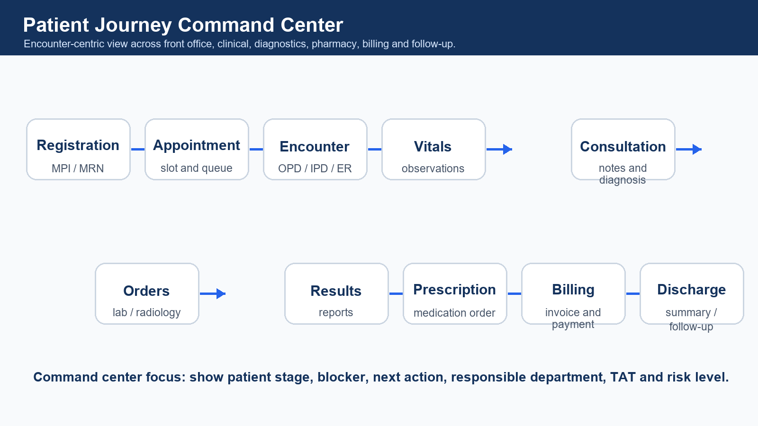
Point-wise patient journey from registration to follow-up.
- The command center should show current stage, waiting time, blocker, next action and responsible department.
- Every stage should connect to encounter_id and branch_id.
- Lab, radiology, pharmacy and billing should use queue and status models for high volume.
- Alerts should highlight discharge blockers, critical lab values, payment delays and pending doctor review.
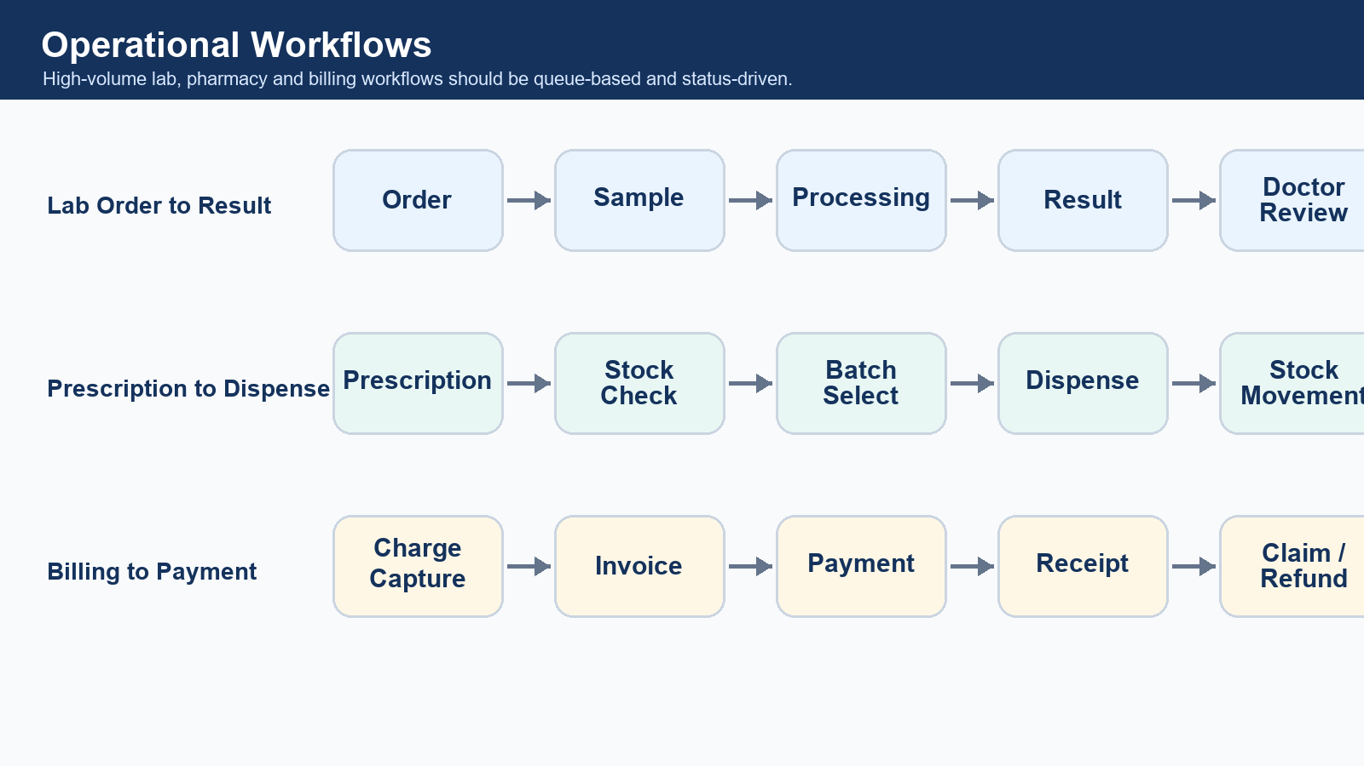
Queue-based operational flows for lab, pharmacy and billing.

13. Branch-Level Access Matrix
Role | Tenant Data | Hospital Data | Branch Data | Clinical Data | Billing Data | Reports | Settings
Platform Super Admin | Subscription/support | Limited metadata | No by default | No by default | No by default | Platform reports | Platform settings
Tenant Admin | All tenant | All hospitals under tenant | All authorized | Policy controlled | Policy controlled | Tenant reports | Tenant settings
Hospital Admin | Own tenant only | Own hospital | All hospital branches | Admin-level allowed | Allowed | Hospital reports | Hospital settings
Branch Admin | No | Own hospital metadata | Own branch | Operational view | Branch financial | Branch reports | Branch settings
Doctor | No | No | Assigned branches | Assigned patients/encounters | Limited or no | Clinical reports | No
Nurse | No | No | Assigned branch/ward | Assigned ward patients | No | Nursing reports | No
Receptionist | No | No | Own branch | Limited demographics | Limited | Queue reports | No
Lab Technician | No | No | Own branch lab | Order/result scope | No | Lab reports | No
Pharmacist | No | No | Own branch pharmacy | Prescription view | Sales scope | Stock reports | No
Billing User | No | No | Own branch billing | Minimal clinical context | Allowed | Collection reports | No

14. API and Microservices Alignment
- Backend services should use Spring Boot microservices or modular services with a shared TenantContext pattern.
- Each service must validate JWT, role permissions and branch permissions before running database queries.
- Critical workflows must use transactions: billing, pharmacy stock movement, lab order, discharge, insurance claim and refunds.
- NamedParameterJdbcTemplate/JDBC can be used if the backend follows a no-JPA approach.
- Every service should emit structured logs and audit events for sensitive operations.
Service | Primary Responsibility | High-Risk Operations
Auth Service | Login, JWT, roles, permissions | Token generation, branch claims.
Hospital Service | Tenant, hospital, branch setup | Branch activation/deactivation.
Patient Service | Patient registration and identifiers | Duplicate patient merge.
Encounter Service | OPD, IPD, ER visit lifecycle | Admission, transfer, discharge.
Lab Service | Lab order, sample, result | Critical result reporting.
Pharmacy Service | Prescription, stock, dispensing | Batch stock deduction.
Billing Service | Invoices, payments, refunds | Payment posting and refund reversal.
FHIR Gateway Service | FHIR mapping and API | External PHI exchange.
HL7 Integration Service | HL7 listener/parser/message log | Inbound/outbound message replay.
Reporting Service | Summary tables and dashboards | Large report generation.
Audit Service | Audit log and access log | Break-glass and sensitive access tracking.

15. Reporting, Analytics and AI Readiness
- Do not run heavy dashboards directly from normalized transaction tables.
- Use scheduled aggregation jobs, event-based aggregation or materialized views where supported.
- Create branch-wise, hospital-wise and tenant-wise summary tables.
- For AI, use scoped, audited, optionally de-identified datasets.
- Command center should focus on operational action, not only charts.
Dashboard | Summary Table Example | Business Question
Daily OPD | daily_patient_visit_summary | How many patients visited each branch and department today?
IPD occupancy | bed_occupancy_summary | Which branches have bed pressure?
Revenue | daily_branch_revenue_summary | Which branch and department generated revenue?
Lab volume | lab_test_volume_summary | Where are sample/result delays happening?
Pharmacy | pharmacy_stock_snapshot | Which medicines are low stock or near expiry?
Discharge TAT | patient_journey_summary | Where are discharge blockers occurring?

16. Backup, Disaster Recovery and Enterprise Deployment
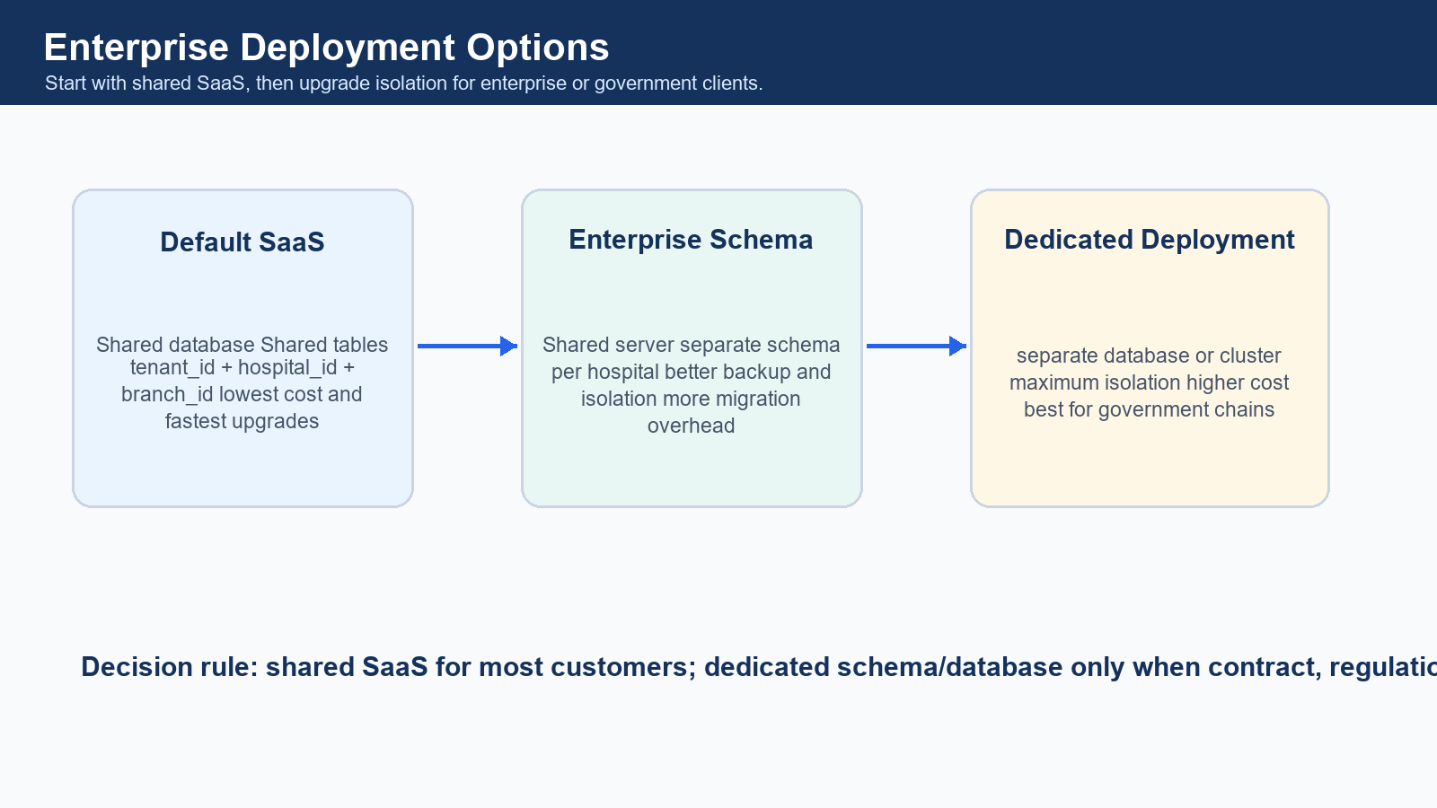
Deployment options from shared SaaS to dedicated enterprise database.
- Shared SaaS database should have full backups, point-in-time recovery and tested restore procedures.
- Hospital-wise logical backup should be supported for enterprise support and migration needs.
- Branch-wise restore is difficult in shared tables and should be handled carefully with audit review.
- FHIR and HL7 message logs should support replay for integration recovery.
- Audit logs should follow retention policy and should not be silently deleted.

17. Implementation Roadmap
Phase | Name | Scope | Success Output
1 | Foundation | Tenant, hospital, branch, users, roles, patients, appointments | Secure multi-tenant base ready.
2 | Clinical Core | Encounter, vitals, diagnosis, notes, prescription | Doctor and nursing workflows operational.
3 | Revenue Cycle | Billing, payments, refunds, insurance | Financial workflow controlled and auditable.
4 | Diagnostics and Pharmacy | Lab, radiology, medicine inventory, dispensing | Order-to-result and prescription-to-dispense ready.
5 | FHIR and HL7 Layer | FHIR mapper/API, HL7 listener/parser/logs | Interoperability with external systems.
6 | Advanced Operations | IPD, emergency, surgery, discharge, housekeeping, ambulance | End-to-end hospital operations.
7 | Analytics and AI | Summary tables, dashboards, patient journey command center | Leadership and operations intelligence.

18. Final Recommendations
Architecture recommendations
- Default architecture should be shared database and shared tables.
- Every transaction table must contain tenant_id, hospital_id and branch_id.
- Patient should generally be hospital-level; encounter should be branch-level.
- Use normalized tables for correctness and audit.
- Use denormalized summaries for dashboards and reports.
- FHIR should be an interoperability layer, not the only database structure.
- Maintain HL7 message logs for traceability and replay.
- Never trust frontend for tenant or branch isolation.
- Backend must enforce data access using JWT claims, TenantContext and BranchContext.
- Use dedicated schema/database only for enterprise, government or compliance-heavy contracts.

19. Appendix

Database Naming Convention
- Use snake_case table and column names.
- Use id as primary key and UUID/public identifier where external reference is required.
- Use tenant_id, hospital_id and branch_id consistently.
- Use created_at, created_by, updated_at, updated_by and is_deleted on operational tables.
- Use status fields with controlled values and lookup/reference tables where appropriate.

Indexing Examples
CREATE INDEX idx_patient_tenant_hospital
ON patients (tenant_id, hospital_id, mrn);
CREATE INDEX idx_encounter_branch_date
ON encounters (tenant_id, hospital_id, branch_id, start_time);
CREATE INDEX idx_invoice_branch_date
ON billing_invoices (tenant_id, hospital_id, branch_id, invoice_date);
CREATE INDEX idx_lab_order_status
ON lab_orders (tenant_id, hospital_id, branch_id, status, ordered_at);

FHIR Glossary
FHIR Resource | Meaning in HMS
Patient | Person receiving care.
Encounter | Visit/admission/emergency/virtual care event.
Observation | Vitals, lab values and clinical measurements.
ServiceRequest | Lab, radiology, procedure or diagnostic order.
DiagnosticReport | Diagnostic report output.
MedicationRequest | Prescription or medication order.
MedicationDispense | Medicine dispensing event.
DocumentReference | PDF, scan, report, note or uploaded document.
AuditEvent | Security and compliance trace event.

HL7 Message Glossary
HL7 Message | Meaning
ADT | Admission, discharge and transfer events.
ORM | Order message, commonly used for lab/radiology orders.
ORU | Observation/result message.
SIU | Scheduling message.
DFT | Financial transaction message.
MDM | Medical document management message.

